GTB  
  
**QA**  
[DEV 20.30] OT-839 | AB | DE | SHOWROOM | New Vehicles in "Family Car" Section(s) (946) – 10 August 2020

**Jira ticket:**  
<https://jira.uhub.biz/browse/GTBEMEAOPT-946>

**Site**  
<https://www.ford.de/>

**Test location**  
Mini Showroom, HP Car Slider, Showroom, BP Showroom

**Hypothesis**

We assume that offering 3 additional vehicles (Focus, Mondeo, Tourneo Courier) for category "family cars" (Familienautos) will result in more visits for these three vehicles. Currently, these vehicles are not included in this category due to GUX governance rules.

**Test Description**  
  
View the QA Link. On the home page scroll down to the section that says “Für jeden Lebensstil das passende Auto” the section below that is referred to a Homepage Car Slider. Select the Familienautos option on the car slider, the Ford Focus, Ford Mondeo and the Ford Tourneo Courier should have been added to the end of this slide. See image 1 for an example.

Next check the mini showroom. It can be found by mousing over Modelle, found on the main navigation bar in the top left, then clicking on the Familienautos option. The Ford Focus, Ford Mondeo and the Ford Tourneo Courier should have been added into the section. See image 2 for an example.

Next check the BnP Showroom, by clicking on the Konfigurator, found on the main navigation bar in the top right. Once on this page filter by the Familienautos option. The Ford Focus, Ford Mondeo and the Ford Tourneo Courier should have been added into the section. See image 3 for an example.

Lastly check the Vehicles page, by mousing over Kaufberatung, found on the main navigation bar in the top left next to Modelle, then clicking on the Alle PKW entdecken option which is on the left under the Informieren heading. Once on this page filter by the Familienautos option. The Ford Focus, Ford Mondeo and the Ford Tourneo Courier should have been added into the section. See image 4 for an example.  
  
If you would like to know what it normally looks like you can visit the control link and follow the same instructions. However, the vehicles would not be added.

Image 1: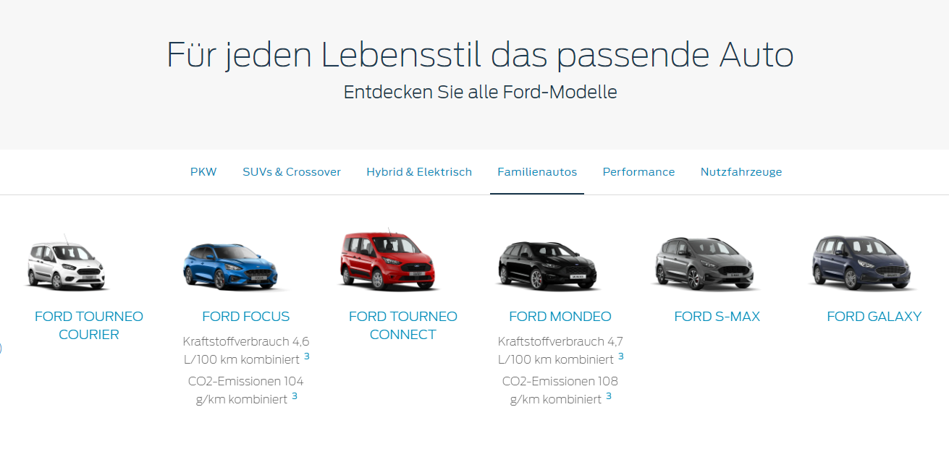

Image 2: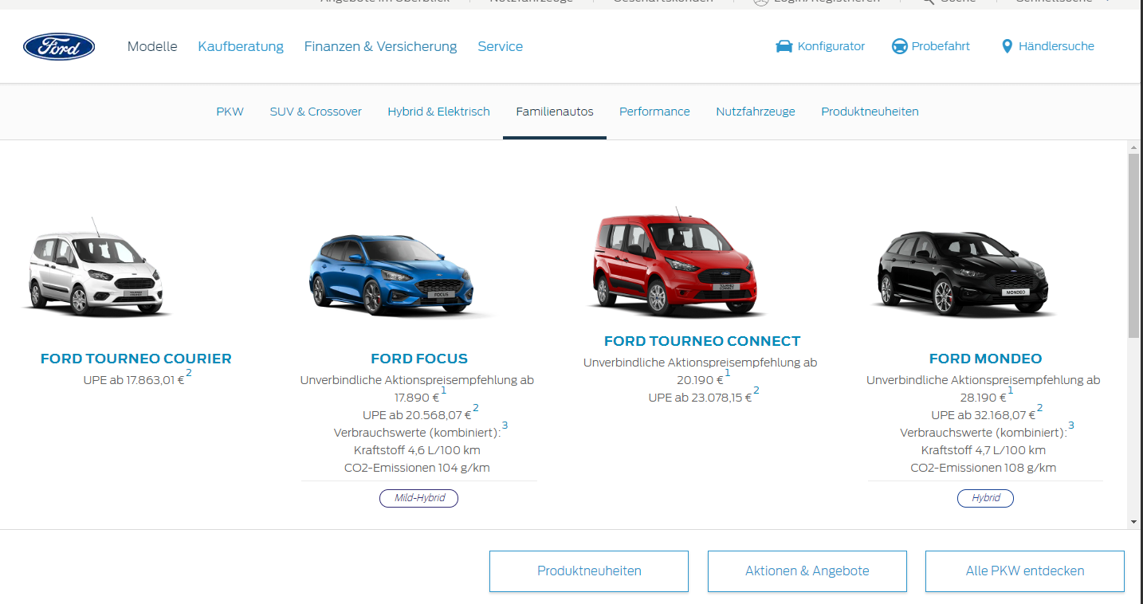

Image 3: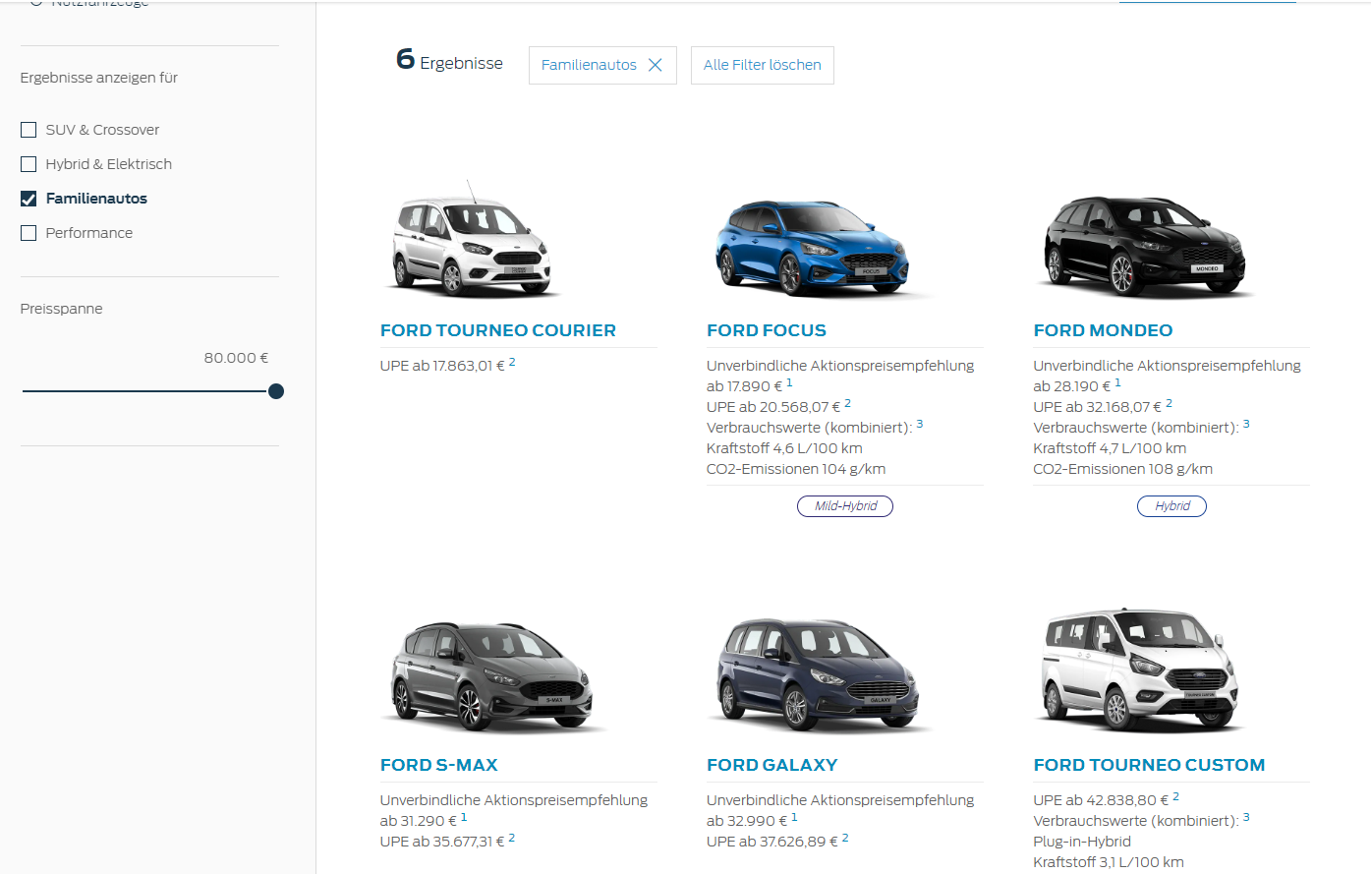

Image 4: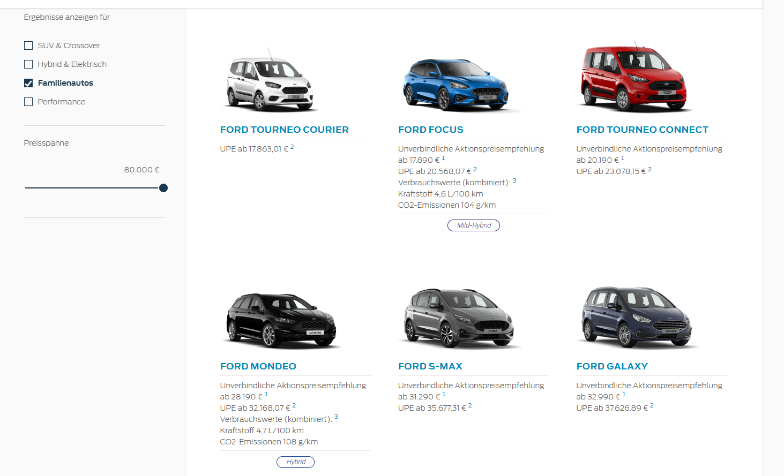

**Browser:**   
All  
  
**Device:**   
All  
  
**Audience rules:**   
All traffic

**QA Links:**

**CONTROL:**

<https://www.ford.de?at_preview_token=zsctgjhht6wwIQ4YolUVqw&at_preview_index=1_1&at_preview_listed_activities_only=true>

**CHALLENGER:**

<https://www.ford.de?at_preview_token=zsctgjhht6wwIQ4YolUVqw&at_preview_index=1_2&at_preview_listed_activities_only=true>